*Use the information in Chapter 6 (p.94-122) to complete the following reading guide. Bozeman’s podcast on [Cellular Organelles](http://www.bozemanscience.com/043-cellular-organelles) would be helpful to watch before reading the chapter.*

**Concept 6.1: Biologists use microscopes and the tools of biochemistry to study cells**

List the structures you would be able to view with each of the following types of microscopes:

* Light microscope
* Scanning electron microscope
* Transmission electron microscope

How does the process of cell fractionation allow us to view organelles and other sub-cellular structures?

**Concept 6.2: Eukaryotic cells have internal membranes that compartmentalize their functions**

Complete the following table to compare and contrast prokaryotes and eukaryotes.

|  |  |  |
| --- | --- | --- |
| Prokaryotes | Both | Eukaryotes |
|  |  |  |

Draw and label a diagram showing the major structures of a bacterium.

Use the following images to explain why surface area to volume ratio is critical to the survival of cells.

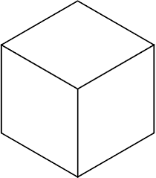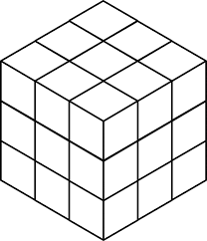

**Concept 6.3: The eukaryotic cell’s genetic instructions are housed in the nucleus and carried out by the ribosomes**

Complete the table below to organize information about the following cellular structures.

|  |  |
| --- | --- |
| **Structure** | **Function** |
| Nucleus |  |
| Nuclear envelope |  |
| Nuclear lamina |  |
| Chromosomes |  |
| Chromatin |  |
| Nucleolus |  |
| Free ribosomes |  |
| Bound ribosomes |  |

**Concept 6.4: The endomembrane system regulates protein traffic and performs metabolic functions in the cell**

Complete the table below to organize information about the following cellular structures.

|  |  |
| --- | --- |
| **Structure** | **Function** |
| Smooth endoplasmic reticulum |  |
| Rough endoplasmic reticulum |  |
| Transport vesicles |  |
| Golgi apparatus |  |
| Lysosome |  |
| Food vacuole |  |
| Central vacuole |  |

**Concept 6.5: Mitochondria and chloroplasts change energy from one form to another**

Complete the table below to organize information about the following cellular structures.

|  |  |
| --- | --- |
| **Structure** | **Function** |
| Mitochondrion |  |
| Chloroplast |  |
| Peroxisome |  |

**Concept 6.6: The cytoskeleton is a network of fibers that organizes structures and activities in the cell**

Complete the table below to organize information about the following cellular structures.

|  |  |
| --- | --- |
| **Structure** | **Function** |
| Cytoskeleton |  |
| Motor protein |  |
| Microtubules |  |
| Centrosome |  |
| Centrioles |  |
| Flagella |  |
| Cilia |  |
| Microfilaments |  |

**Concept 6.7: Extracellular components and connections between cells help coordinate cellular activities**

Complete the table below to organize information about the following cellular structures.

|  |  |
| --- | --- |
| **Structure** | **Function** |
| Tight junctions |  |
| Desmosomes |  |
| Gap junctions |  |